Themes covered
Each week of the course is dedicated to a particular theme. All activities for the week are aimed at enhancing the participants’ knowledge, skills and attitudes surrounding that theme. The themes or key focus areas selected are derived from extensive research. The New Futures Programme team has consulted a range of recruitment agents and ICT companies to find out from them what skills and attitudes potential employees needed to be successful. In this way the Programme interventions were matched with authentic marketplace demands.

The curriculum for the Programme is broadly broken into two areas, namely ICT technical support skills and employability or the so called ‘soft skills’.

ICT Technical Support Skills
- Understanding hardware
- Understanding and installing Operating System software
- Introduction to and practicing troubleshooting
- Supporting hardware (e.g. hard drives, USB ports, RAM)
- Supporting networked computers
- Accessing and using the Internet
- Supporting security needs
- Performing routine maintenance

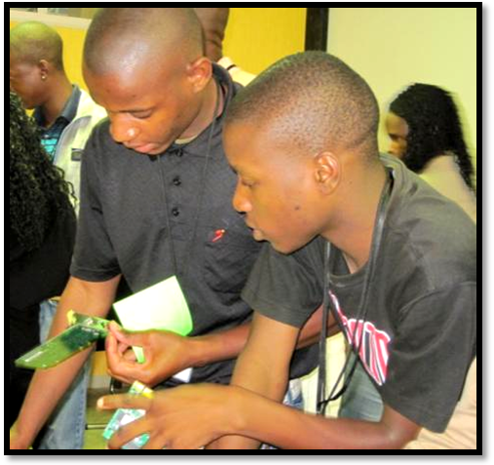
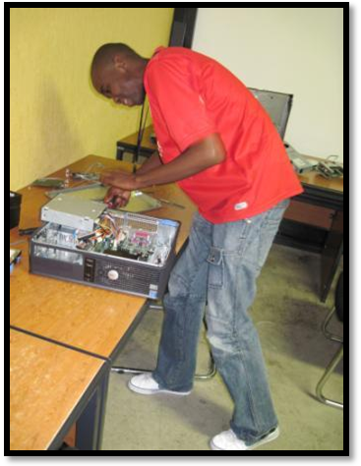

Participants dismantling and reassembling desktops.
Employability Skills
- Navigating the world of work
- Effective communication
- Business presentation skills
- Exploring entrepreneurship and starting a business
- Personal financial literacy
- Understanding NGOs and their ICT support and planning needs
- Business writing skills
- Team work
- Effective planning
- Critical thinking and problem solving
- Citizenship and personal responsibility

Project-based approach to learning

The New Futures programme is based on project based learning (PBL) principles. PBL is defined by the Buck Institute of Education (2003) as ‘a systematic teaching method that engages students in learning knowledge and skills through an extended inquiry process structured around complex, authentic questions and carefully designed products and tasks.’ Students are pulled through the curriculum by a driving or primary question or authentic problem that creates a need to know the material. Two key attributes of projects designed on PBL principles are the following:

- Projects recognise learners’ inherent drive to learn and their need to be taken seriously by putting them at the centre of the learning process;
- Projects highlight challenging issues or questions that lead learners to in-depth exploration of authentic and important topics.

The programme’s learning facilitators assists learners, working in teams, to gain necessary skills through relevant learning projects using authentic scenarios. Each learning project aims to integrate some, if not all, the curriculum areas mentioned above. The development of learning projects is an ongoing process, designed to integrate learners’ abilities, needs and interests. As far as is possible and realistic, the programme seeks to simulate the world of work and results in learners developing products that demonstrated mastery of skills and abilities.

Programme delivery

Facilitators aim to provide an environment where learners can take responsibility for their own learning. Learners are given a primary question which is derived from the overall expected outcome of the session. The participants then came up with secondary questions which help them to answer the primary question. Various experiential learning activities are designed and then used to answer these questions. Some of these activities include research leading to presentations, role plays, interviews, written reports, debates and brainstorming sessions. The incorporation of an activity-based approach means that important knowledge and skills are learnt by doing.

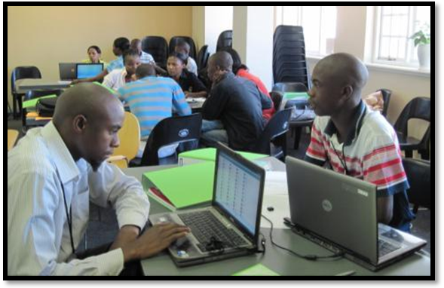

Participants hard at work on a group work project in their first week

Guest Speakers and Facilitators

Over and above the regular learning projects designed by the team, the programme delivery was enriched by the participation of a number of guest speakers. Guest speakers told their stories of how they have navigated the world of work and spoke about the skills and attitudes they believe are successful in the marketplace. Some specific guest speaker and topics covered include:
- Leo Pineda and Scott Mills from AED visited participants during their first week on the programme and spoke about the importance of effective communication skills in the workplace, and showed off some new technologies being developed in the United States.
- Annette Kinnear, author of ‘Your Career, Your Life’ spoke about the importance of setting goals, persevering and believing in yourself. Annette founded IRIE Inspiration in 2009 spurred by the Jamaican philosophy that one person can make a difference. The company’s three divisions include Career Design, Corporate Inspiration and Cross Cultural Inspiration.
- Angel Jones, Creative Director of Morrisjones&Co advertising agency and founder of the Homecoming Revolution spoke about the importance of follow one’s dreams and gave some practical tips and advice on starting one’s own company.
- Omashani Naidoo from SchoolNet SA presented a session on financial management. The participants had the opportunity to practice drawing up their own personal budget and learnt the importance of managing one’s finances effectively.
- Staff members from Dependable Strengths ran a 3 day workshop to assist participants in identifying and articulating their strengths. The final outcome was a strengths report which participants presented to members of their community with the aim of being remembered and possibly referred for potential employment.
- Phelelia Sekele from the Sci-Bono Career Centre facilitated a practical workshop on effective CV and cover letter writing for both groups. This was followed by a series of ‘mock interviews’ where participants were interviewed by a panel of Sci-Bono staff members and feedback was given to them to help them improve their interviewing skills.

Job shadowing
Job shadowing at various Johannesburg-based companies is another important component of the programme. Participants spent one week at an IT company or in an IT department within a company. They then returned to the formal programme for a period of two weeks, before returning for another week of job shadowing. The two main objectives of the job shadowing are:
- to provide the participants with an opportunity to familiarise themselves with the industry and to be exposed to organisational culture and structure; and
- to assist the participants in obtaining career exposure so that the participant can make a more informed decision regarding the direction in the ICT sector that they wanted to pursue.
After the first week of job shadowing, the facilitators discussed the feedback received from host companies on the participant’s skills or attitudes that still needed improving.

eMentoring programme
Every participant on the New Futures Programme was assigned an eMentor, a working professional who acted as the participant’s guide, advisor and supporter along their journey. The mentoring relationship provided an opportunity for more experienced people in a variety of industries and professions to provide support and guidance to the participants through modelling positive attitudes and behaviour such as integrity, commitment, professionalism and perseverance. It was referred to as eMentoring because the majority of the interaction was online i.e. through email and instant messaging (IM). Where IM was problematic, the telephone was used.

The goal of eMentoring was similar to face- to- face mentoring, which is to establish a relationship of trust, respect and responsibility between someone experienced and someone less experienced and younger. Part of the aim of online eMentoring on the NFP is to assist the participants (mentees) in improving their reading and writing skills through IM chats and email correspondence. It gives the participants an opportunity to understand the potential benefits of using Internet communication tools. The eMentors supported their mentees by sharing their stories of how they successfully navigated the world of work. Discussing employment opportunities, giving general advice and guidance and helping the mentee to develop a positive attitude to taking responsibility, are all areas that the mentor is likely to engage. Another important aim of this relationship is to assist the mentees in developing professional networks that they otherwise would not have had access to.

